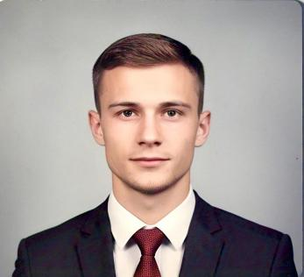

JIBRAN AHMAD

INTERNSHIP

**CONTACT**

6005501083 

[jibranmalik691@gmail.com](https://mailto:jibranmalik691@gmail.com) 

[Mirmaidan Dooru,](https://mailto:jibranmalik691@gmail.com)

[Anantnag](https://mailto:jibranmalik691@gmail.com)

J&K, 192211

15-09-2005 **DOB**

**LANGUAGE LITERECY**

English

Hindi

Kashmiri

Urdu

**KEY SKILLS**

|  |
| --- |
| Above Average, Average, Below Average |

**Resilience**

Average

**Communication Skills**

Average

**Multitasking**

Above Average

**Attention to detail**

Average

**Problem Solving**

Above Average

|  |
| --- |
| **QUALIFICATION SUMMARY** |

* **ACADEMIC**

|  |  |  |  |
| --- | --- | --- | --- |
| **S.No** | **Examination** | **Board** | **%** |
| 1 | 10th | JKBOSE | 68.8% |
| 2 | 12th | JKBOSE | 60.4% |

* **PROFESSIONAL**

|  |  |  |  |
| --- | --- | --- | --- |
| **S.No** | **Examination** | **University** | **Grade** |
| 1 | Diploma in Food Production | NCHMCT | Pursuing |

|  |
| --- |
| **EXTRACURRICULAR ACTIVITIES** |

* Secured 2nd position in State Debate Competition in 2023
* Participated in Police Premier Legue - Cricket Tournament held at Baramulla in 2023
* Azadi Ka Amrit Mahotsav Participant in 2022
* Participated In Swachhta Pakhwada in 2022
* Participated As A Parliamentary Delegate At The Lalit 2020

**HOBBIES**

* Adventure Sports
* Trekking
* Gardening

Reference : Mr. Javaid Ahmad Bhat

Incharge Training & Placement, Institute of Hotel Management, Srinagar (J&K)

Mobile: +91-7889568456.E-mail:[javaidbhat@ihmsrinagar.edu.in](https://mailto:javaidbhat@ihmsrinagar.edu.in)